OUTPUT:
Python Approach
server.py
from xmlrpc.server import SimpleXMLRPCServer
from functools import reduce

factorial= lambda n: reduce(lambda x,y: x*y, range(1,n+1),1)

server= SimpleXMLRPCServer(("localhost", 8000))
print("Server running")

server.register_function(factorial, "factorial")
server.serve_forever()

client.py
import xmlrpc.client

proxy = xmlrpc.client.ServerProxy("http://localhost:8000/")

num = int(input("Enter number: "))
result = proxy.factorial(num)

print("Factorial:", result)

Terminal output:
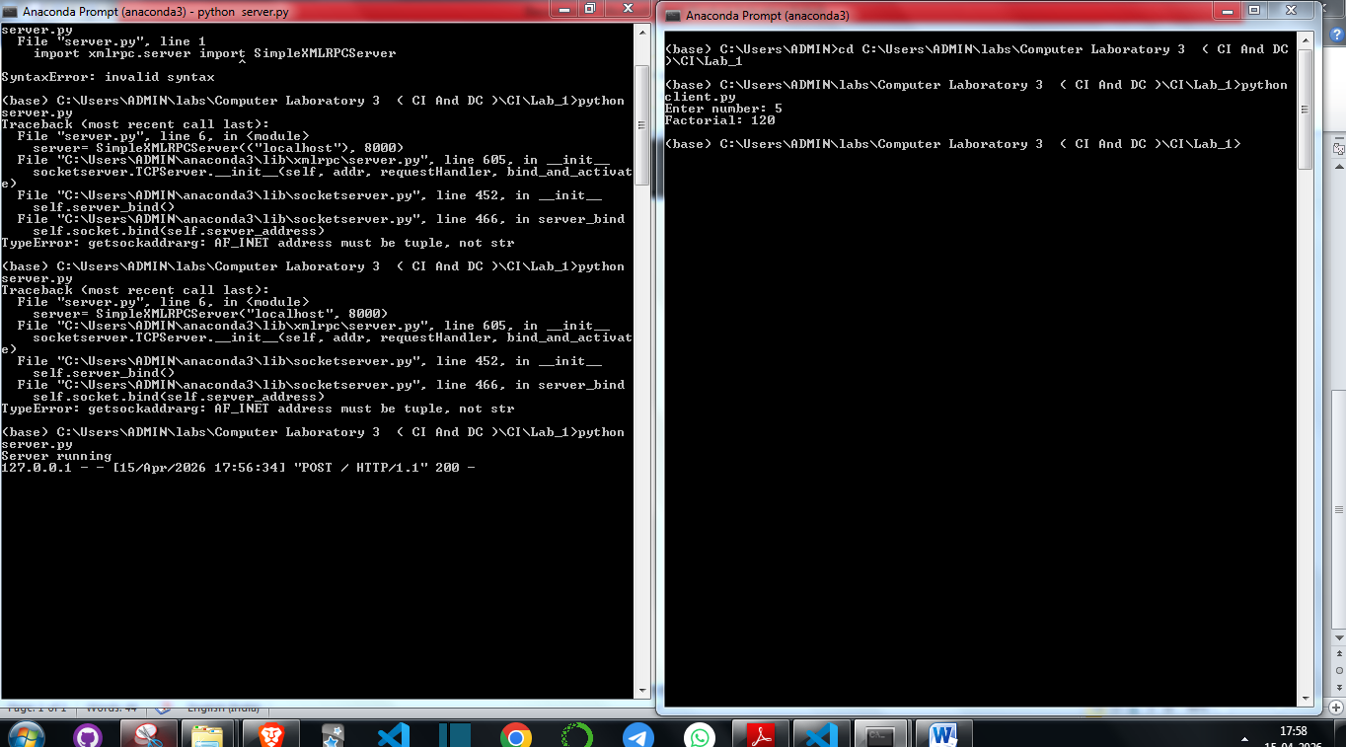
JAVA Implementation:
For BigInt:
import java.rmi.Naming;
import java.math.BigInteger;

public class Client {
public static void main(String[] args) {
try {
Factorial obj = (Factorial) Naming.lookup("rmi://localhost/FactorialService");

int n = 100;
BigInteger result = obj.fact(n);

System.out.println("Factorial of " + n + " is:");
System.out.println(result);

} catch(Exception e) {
e.printStackTrace();
}
}
}

Factorial.java:
import java.rmi.Remote;
import java.rmi.RemoteException;
import java.math.BigInteger;

public interface Factorial extends Remote {
BigInteger fact(int n) throws RemoteException;
}

Server.java:
import java.rmi.Naming;

public class Server {
public static void main(String[] args) {
try {
FactorialImpl obj = new FactorialImpl();
Naming.rebind("rmi://localhost/FactorialService", obj);
System.out.println("Server ready...");
} catch(Exception e) {
e.printStackTrace();
}
}
}

FactorialImpl.java:
import java.rmi.server.UnicastRemoteObject;
import java.rmi.RemoteException;
import java.math.BigInteger;

public class FactorialImpl extends UnicastRemoteObject implements Factorial {

protected FactorialImpl() throws RemoteException {
super();
}

public BigInteger fact(int n) {
BigInteger result = BigInteger.ONE;
for(int i = 1; i <= n; i++) {
result = result.multiply(BigInteger.valueOf(i));
}
return result;
}
}

Terminals:
